Mathematics Methods – ATAR Year 11

Test 1 – Unit 1

Chapters 1, 2 and 8

**Assessment type:** Response

**Conditions:**

Time for the task: 55 minutes, in-class, under test conditions

**Materials required:**

Section One: Calculator-free Standard writing equipment

Section Two: Calculator-assumed Calculator (to be provided by the student)

**Other materials allowed:** Drawing templates, 1 page of notes in Section Two

**Marks available: 50 marks**

Section One: Calculator-free (18 marks)

Section Two: Calculator-assumed (32 marks)

**Task weighting: %**

## Section One: Calculator-free (18 marks)

Suggested time: 20 minutes

**Question 1 (4 marks)**

Use the unit circle shown below to determine each of the following, giving your answers in terms of either a, b, c or d.

390

1

230

Q (c, d)

P (a, b)

$\sin{23°}$

$\cos{51°}$

$\cos{157°}$

1

$\sin{129°}$

**Question 2 (3 marks)**

1. Solve $\sin{x}=-\frac{1}{2}$ for $0≤x≤360°$ (1 mark)
2. Use angle sum or angle difference to show that the exact value of $\sin\left(\frac{7π}{12}\right)$ is $\frac{\sqrt{2}(\sqrt{3}+1)}{4}$ (2 marks)

**Question 3 (7 marks)**

1. The graph of the trigonometric function $y=f(x)$ is shown.

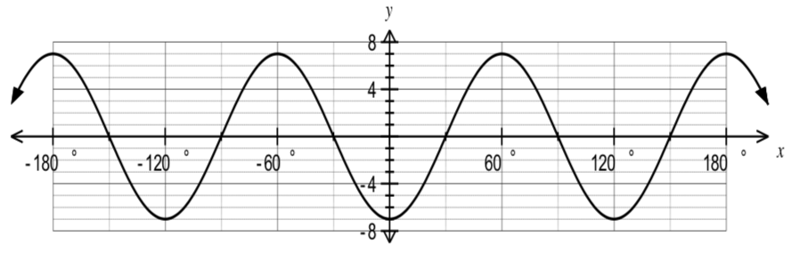

1. State the amplitude of $f(x)$. (1 mark)
2. State the period of $f(x)$. (1 mark)
3. State the equation of the trigonometric function $f(x)$. (2 marks)
4. On the axes below, sketch the graph of  for $0≤x≤π.$ (3 marks)

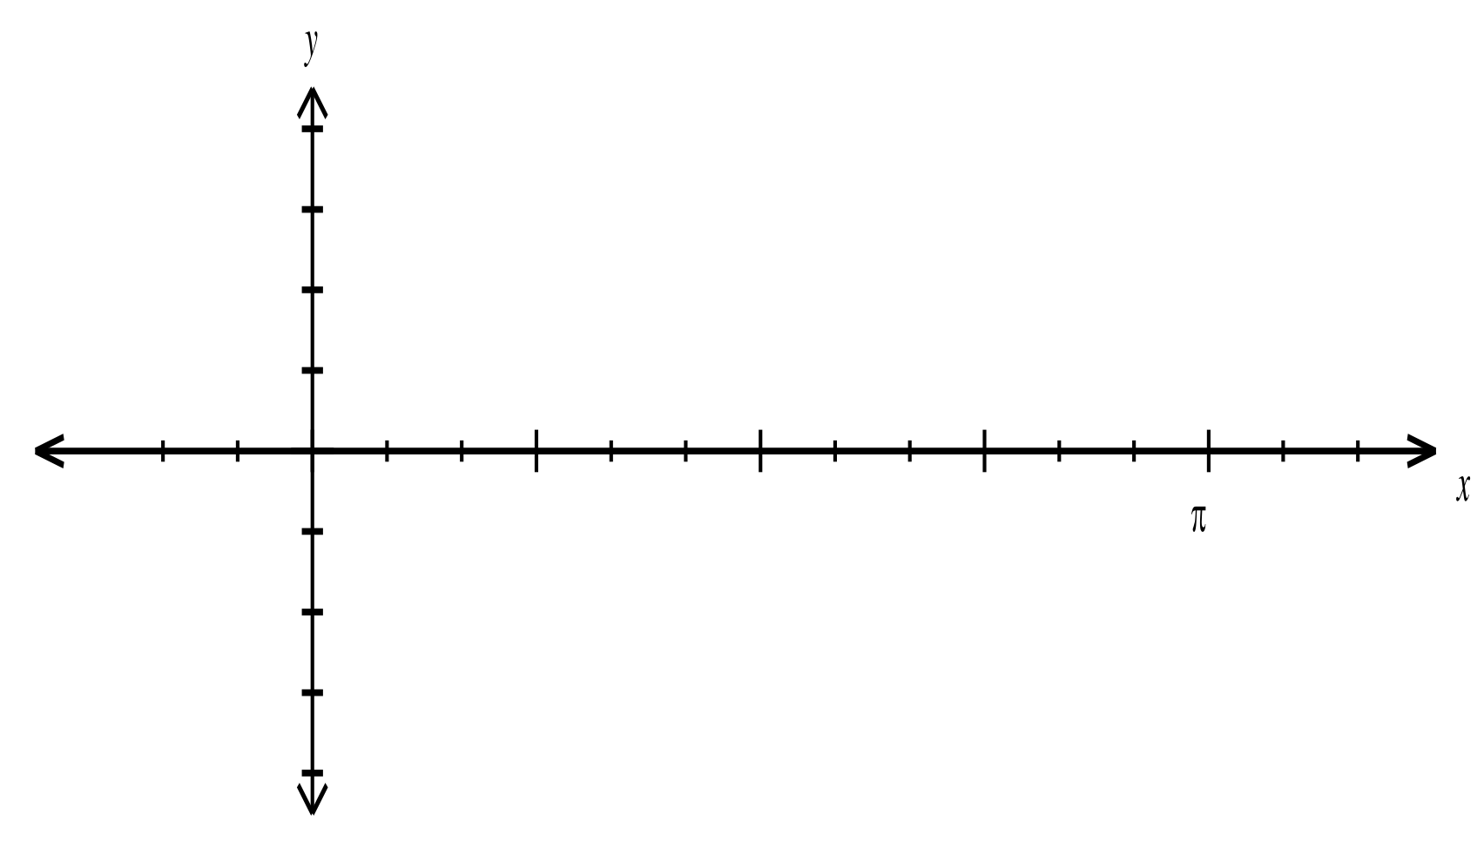

$$π$$

**Question 4 (4 marks)**

For the line 

1. Sketch the line (2 marks)

1. Mark the angle of inclination the line makes with the $x$-axis.

Determine this angle. Justify your answer. (2 marks)

Section Two: Calculator-assumed (32 marks)

Suggested time: 35 minutes

**Question 5** **(6 marks)**

1. Calculate the smallest possible length of AB in the triangle shown below. (3 marks)

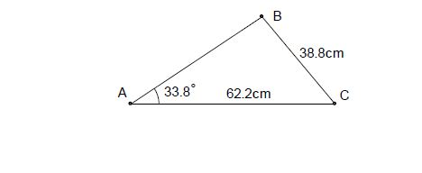*(The triangle is not drawn to scale).*

1. In the diagram below (not to scale), the line AC intersects the line BD at O. The angle AOB=35o, and the lengths OB=14cm, OD=26cm and AC=30cm. If the area of triangle ODC is twice that of triangle OAB, determine the length OA. (3 marks)

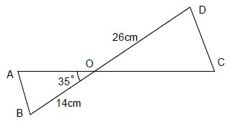

**Question 6** **(9 marks)**

Two circles, one of radius 8cm and the other of radius 18cm, with a common tangent, touch each other as shown in the diagram.

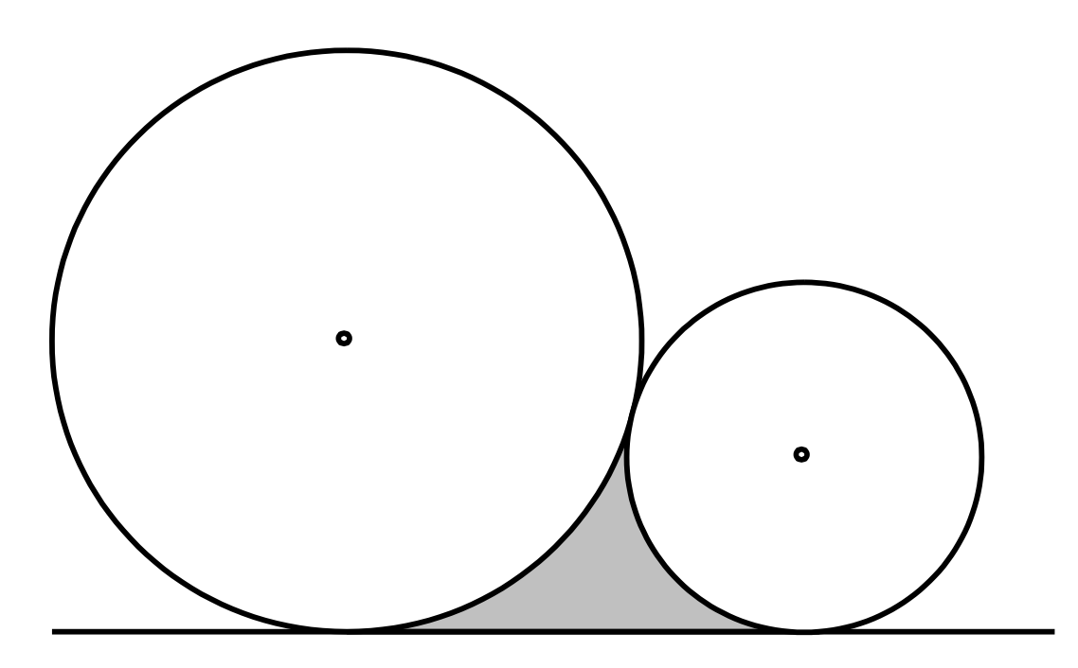

1. Calculate the perimeter of the shaded region. (5 marks)
2. Calculate the area of the shaded region. (4 marks)

**Question 7** **(6 marks)**

1. *A* and *B* are acute angles such that $\sin{A=\frac{3}{5}}$ and $\cos{B=\frac{12}{13}.}$
2. Determine the exact values of $\cos{A}$ and $\sin{B}$. (2 marks)
3. Show that the exact value of $\cos{(A+B)}$ is $\frac{33}{65}$. (2 marks)
4. *A* and *B* are obtuse angle such that $\sin{A=\frac{3}{5}}$ and $\cos{B=\frac{12}{13}}$. Determine the exact value of $cos({A-B)}$. (2 marks)

**Question 8** **(5 marks)**

1. Simplify $\sin\left(A+B\right)-\sin{(A-B)}$. (1 mark)
2. Solve
3. $2\sin{{}_{}^{2}x-1=0, 0≤x≤2π}$. (2 marks)
4. $2\cos{{}_{}^{2}{3x+\cos{3x=0, -90<x<90}}}$. (2 marks)

**Question 9** **(6 marks)**

1. Use the angle sum and difference identities to show that
2. $\cos\left(2A\right)=\cos{{}_{}^{2}{A-\sin{{}_{}^{2}A}}}$. (1 mark)
3. $\sin{A=\cos{(90°-A)}}$. (1 mark)
4. The exact values of the sine and cosine of $36°$ are $\frac{\sqrt{10-2\sqrt{5}}}{4}$ and $\frac{1+\sqrt{5}}{4}$ respectively.

Use both identities from (a) to show that the exact value of the sine of $18°$ is $\frac{\sqrt{5}-1}{4}$. (4 marks)